Unit – 1
INTRODUCTION TO SOFTWARE:
- Software is a set of instructions used to acquire inputs and to manipulate them to produce the desired output in terms of functions and performance as determined by the user of the software.
- It also includes a set of documents, such as the software manual, meant to help users understand the software system.
- Today’s software is comprised of Source Code, Executables, Design Documents, Operations, and System Manuals and Installation and Implementation Manuals.
- Software includes:
- (i) Instructions (computer programs) that when executed provide desired
- functions and performance.
- (ii) Data structures that enable the programs to adequately manipulate
- information.
- (iii) Documents that describe the operation and use of the programs.
Definition of software given by the IEEE:
- Software is the collection of computer programs, procedure rules and associated documentation and data.
Importance of Software:
Computer software has become a driving force.
- It is the engine that drives business decision making.
- It serves as the basis for modern scientific investigation and engineering problem-solving.
- It is embedded in all kinds of systems, such as transportation, medical, tele- communications, military, industrial processes, entertainment, office products, etc.
SOFTWARE CHARACTERISTICS:
The key characteristics of software are as follows:
1. Most software is custom-built, rather than assembled from existing components. Most software continues to be custom built, although recent developments tend to be component-based. Modern reusable components encapsulate both data and the processing applied to data, enabling the software engineer to create new applications from reusable parts. For example, today a GUI is built using reusable components that enable the creation of graphics windows, pull-down menus, and a wide variety of interaction mechanisms. The data structures and processing details required to build the interface are contained in a library of reusable components for interface construction.
2. Software is developed or engineered; it is not manufactured in the classical sense. Although some similarities exist between software development and hardware manufacturing, the two activities are fundamentally different. In both activities, high quality is achieved through good design, but the manufacturing phase for hardware can introduce quality problems that are non existent for software. Both activities depend on people, but the relationship between people applied and work accomplished is entirely different. Both require the construction of a “product.” But the approaches are different. Software costs are concentrated in engineering. This means that software projects cannot be managed as if they were manufacturing projects.
Software is flexible. We all feel that software is flexible. A program can be developed to do almost anything. Sometimes, this characteristic may be the best and may help us to accommodate any kind of change. Reuse of components from libraries help in reduction of effort. Now-a-days, we reuse not only algorithms but also data structures.
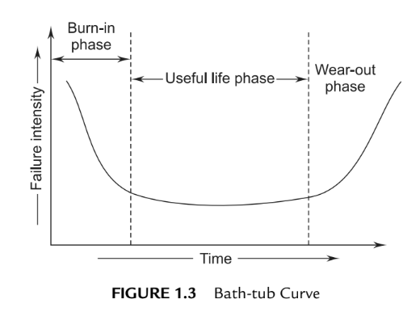
Software doesn’t wear out. There is a well-known “bath-tub curve” in reliability studies for hardware products. Figure 1.3 depicts the failure rate as a function of time for hardware. The relationship is often called the “bath-tub curve.”

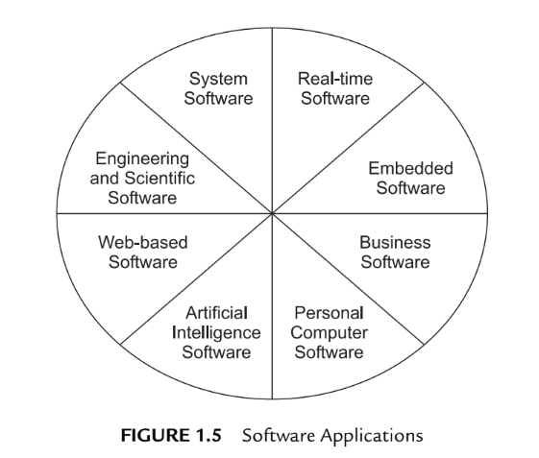
SOFTWARE APPLICATION DOMAINS:
Software applications are grouped into eight areas for convenience as shown in Figure 1.5.
- System Software: System software is a collection of programs used to run the system as an assistance to other software programs. The compliers, editors, utilities, operating system components, drivers, and interfaces are examples of system software. This software resides in the computer system and consumes its resources. A computer system without system software cannot function.
System software directly interacts with the hardware, heavy usage by multiple users, concurrent operations that require scheduling, resource sharing, and sophisticated process management, complex data structures, and multiple external interfaces.
- Real-time Software: Real-time software deals with a changing environment. First, it collects the input and converts it from analog to a digital, control component that responds to the external environment and performs the action.
The software is used to monitor, control, and analyze real-world events as they occur. Examples include Rocket launching, games, etc.
- Embedded software—resides within a product or system and is used to implement and control features and functions for the end user and for the system itself. Embedded software can perform limited and esoteric functions (e.g., key pad control for a microwave oven) or provide significant function and control capability (e.g., digital functions in an automobile such as fuel control, dashboard displays, and braking systems).
- Business Software. Software designed to process business applications is called business software. Business software can be a data- and information- processing application. It can drive the business process through transaction processing in on-line or in real-time mode.
This software is used for specific operations, such as accounting packages, management information systems, payroll packages, and inventory management. Business software restructures existing data in order to facilitate business operations or management decision-making. It also encompasses interactive computing. It is integrated software related to a particular field.
- Personal Computer Software. Word processing, spreadsheets, computer graphics, multimedia, entertainment, database management, personal and business financial applications, external networks, or database access are only a few of hundreds of applications.
- Web applications—called “WebApps,” this network-centric software category spans a wide array of applications. In their simplest form, WebApps can be little more than a set of linked hypertext files that present information using text and limited graphics. However, as Web 2.0 emerges, WebApps are evolving into sophisticated computing environments that not only provide stand-alone features, computing functions, and content to the end user, but also are integrated with corporate databases and business applications.
- Engineering and Scientific Software: The design and engineering of scientific software deals with processing requirements in their specific fields. They are written for specific applications using the principles and formulae of each field.
These software applications service the need for drawing, drafting, modeling, lead calculations, specifications-building, and so on. Dedicated software is available for stress analysis or for analysis of engineering data, statistical data for interpretation, and decision-making. CAD/CAM/CAE packages, SPSS, MATLAB, and circuit analyzers are typical examples of such software.
- Artificial-intelligence Software: Artificial-intelligence software uses non-numerical algorithms, which use the data and information generated in the system to solve complex problems. These problem scenarios are not generally amenable to problem-solving procedures, and require specific analysis and interpretation of the problem to solve it.
Applications within this area include robotics, expert systems, pattern recognition (image and voice), artificial neural networks, theorem proving and game playing, and signal-processing software.
Legacy Software:
- A legacy system is not necessarily defined by age. Legacy may refer to lack of vendor support or a system's incapacity to meet organizational requirements. For example, a large mainframe may use a 64-bit Java, while a Linux platform might utilize code from the 1960s. Legacy conditions refer to a system's difficulty (or inability) to be maintained, supported or improved. A legacy system is usually incompatible with newly purchased systems.
- Legacy systems are high maintenance and may involve intricate patching and modifications. Porting techniques are often used for software adjustments or adaptation. Older hardware may require added compatibility layers to facilitate device functionality in incompatible environments.
- In IT, a legacy system is one that's old and outdated, but still in use. A legacy system might be an antique piece of computer hardware, an application that's past its prime, or some old-fashioned process... or all of the above.
An organization might continue to use legacy systems for a wide range of reasons, such as the following:
- "If it ain't broke, don't fix it!" The system might work adequately.
- The system is complex, and documentation is poor. Simply defining scope can be difficult.
- A redesign is costly, due to complexity or monolithic architecture.
Why are legacy systems still used?
- Legacy systems tend to stick around because they still work and get the job done (if it ain't broke, then don't fix it). Often, they're so old that no one knows exactly how they work anymore or what dependencies they might have, so it could be risky to replace them.
- This problem can be made worse when the vendor that created the legacy hardware or software goes out of business, making performing updates or upgrades much harder. Additional difficulties arise when the employees who deployed these systems left long ago without leaving adequate documentation.
- Another reason you'll encounter legacy systems is because they're so expensive to replace that a company can't afford to switch to a newer version. Or perhaps the legacy application requires proprietary hardware, so you're stuck with really old hardware you can't replace. As a result, you might find ancient, discolored systems next to brand new servers running the latest and greatest of everything.
Legacy Systems Concerns
- The big problem with legacy systems is that they are often so old, they're more prone to failure and they could cost a lot of money to fix when they do. Not only are old parts often hard to find, tracking down someone with the expertise to fix or modify decades-old software could be a very expensive proposition.
- Additionally, legacy systems pose a big security risk. With legacy devices, the operating systems and firmware running on them probably haven't been updated in a long time. And because they're probably no longer supported, new exploits discovered on legacy systems might never be patched.
Legacy Systems Examples
- Hardware in power plants that's so old, the only functioning replacement parts are in the Smithsonian Museum, and the only qualified techs that can repair it are all retired
- A still-in-use voicemail system that uses both software and hardware from 1993
- Software that keeps score in bowling alleys that runs on Zilog Z80 or Intel 486 machines
- A manufacturing machine controlled by decades-old computer running MS-DOS
- Financial software running on an outdated Apple IIGS machine because "it still works"
- Electronic microscopes powered by Windows 95 computers
- Software that requires you to plug a dongle into a parallel port for copy protection purposes, so you're forced to use an ancient system
- Sales terminals running on Intel 286 computers because the software is incompatible with anything newer
- US Department of Defense computers used to operate nuclear weapons still running on computers from the 1970s at a cost of billions of dollars each year to taxpayers
INTRODUCTION TO SOFTWARE ENGINEERING
Software engineering eventually results in a product that is efficient and effective at solving a problem or fulfilling a duty. Following software engineering principles helps to ensure that the product is reliable and safe for customers.
IEEE Comprehensive Definition. Software Engineering is the application of a systematic, disciplined, quantifiable approach to the development, operation and maintenance of software, i.e., the application of engineering to software.
Other Definitions. Software Engineering deals with cost-effective solutions to practical problems by applying scientific knowledge in building software artifacts in the service of mankind.
OR
Software Engineering is the application of methods and scientific knowledge to create practical cost-effective solutions for the design, construction, operation and maintenance of software.
Software-Engineering Principles:
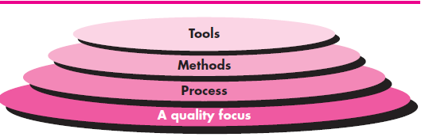
A layered approach
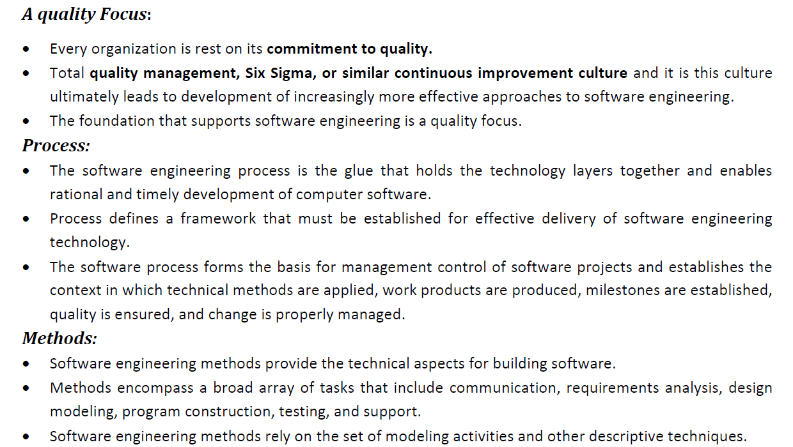
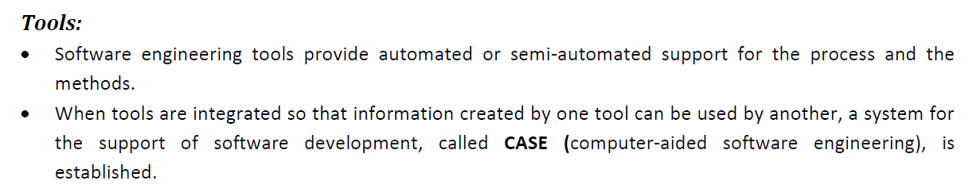
THE SOFTWARE PROCESS
- A process is a collection of activities, actions, and tasks that are performed when some work product is to be created.
- An activity strives to achieve a broad objective (e.g., communication with stakeholders) and is applied regardless of the application domain, size of the project, complexity of the effort, or degree of rigor with which software engineering is to be applied.
- An action (e.g., architectural design) encompasses a set of tasks that produce a major work product (e.g., an architectural design model).
- A task focuses on a small, but well-defined objective (e.g., conducting a unit test) that produces a tangible outcome.
- In the context of software engineering, a process is not a rigid prescription for how to build computer software. Rather, it is an adaptable approach that enables the people doing the work (the software team) to pick and choose the appropriate set of work actions and tasks.
- A process framework establishes the foundation for a complete software engineering process by identifying a small number of framework activities that are applicable to all software projects, regardless of their size or complexity. In addition, the process framework encompasses a set of umbrella activities that are applicable across the entire software process. A process framework establishes the foundation for a complete software engineering process by identifying a small number of framework activities that are applicable to all software projects, regardless of their size or complexity. In addition, the process framework encompasses a set of umbrella activities that are applicable across the entire software process.
A generic process framework for software engineering encompasses five activities:
- Communication. Before any technical work can commence, it is critically important to communicate and collaborate with the customer and other stakeholders. The intent is to understand stakeholders’ objectives for the project and to gather requirements that help define software features and functions.
- Planning. Any complicated journey can be simplified if a map exists. A software project is a complicated journey, and the planning activity creates a “map” that helps guide the team as it makes the journey. The map—called a software project plan—defines the software engineering work by describing the technical tasks to be conducted, the risks that are likely, the resources that will be required, the work products to be produced, and a work schedule.
- Modeling. Modeling is to understand the big picture—what it will look like architecturally, how the constituent parts fit together, and many other characteristics. If required, the sketch is redefined into greater and greater detail in an effort to better understand the problem and identifying the solution. A software engineer does the same thing by creating models to better understand software requirements and the design that will achieve those requirements.
- Construction. This activity combines code generation (either manual or automated) and the testing that is required to uncover errors in the code.
- Deployment. The software (as a complete entity or as a partially completed increment) is delivered to the customer who evaluates the delivered product and provides feedback based on the evaluation.
Umbrella Activities:
- Software engineering process framework activities are complemented by a number of umbrella activities.
- These are:
- Software project tracking and control—allows the software team to assess progress against the project plan and take any necessary action to maintain the schedule.
- Risk management—assesses risks that may affect the outcome of the project or the quality of the product.
- Software quality assurance—defines and conducts the activities required to ensure software quality.
- Technical reviews—assesses software engineering work products in an effort to uncover and remove errors before they are propagated to the next activity.
- Measurement—defines and collects process, project, and product measures that assist the team in delivering software that meets stakeholders’ needs; can be used in conjunction with all other framework and umbrella activities.
- Software configuration management—manages the effects of change throughout the software process.
- Reusability management—defines criteria for work product reuse (including software components) and establishes mechanisms to achieve reusable components.
- Work product preparation and production—encompasses the activities required to create work products such as models, documents, logs, forms, and lists.
A GENERIC PROCESS MODEL
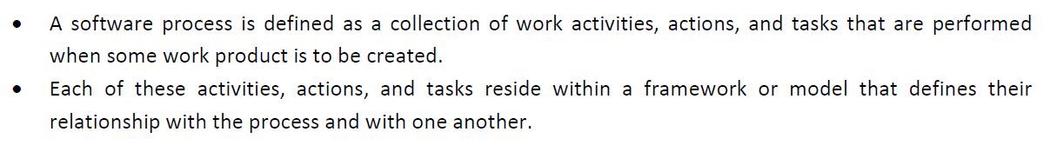

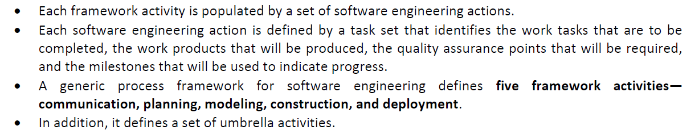

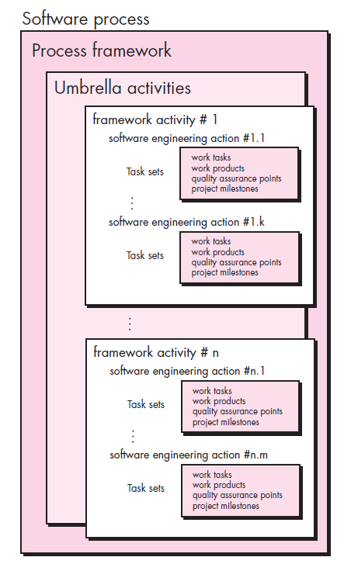
PROCESS FLOW
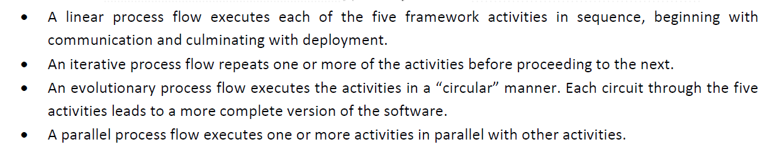

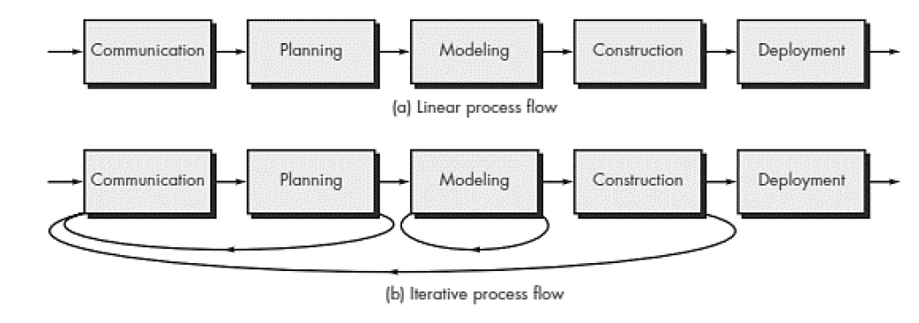
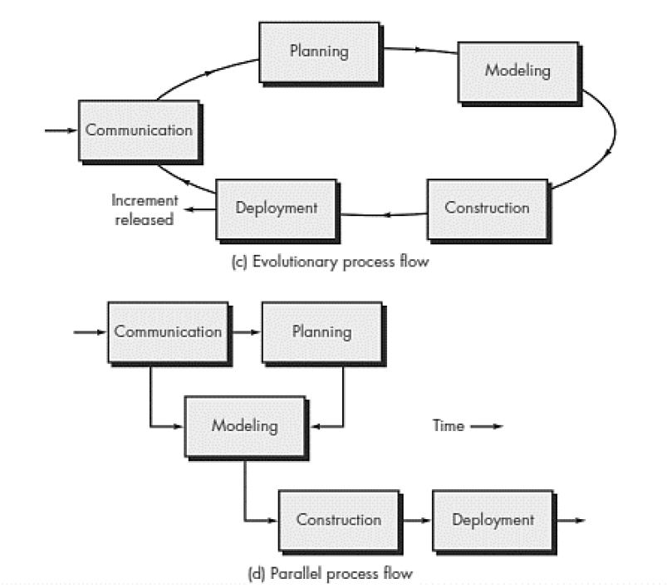
Generic framework focuses on the following:
- Defining a Framework Activity
- Identifying a Task Set
- Process Patterns
a)Defining a Framework Activity
- A software team would need significantly more information before it could properly execute any one of these activities as part of the software process.
- Therefore, key questions: What actions are appropriate for a framework activity, given the nature of the problem to be solved, the characteristics of the people doing the work, and the stakeholders who are sponsoring the project?
b) Identifying a Task Set
- Each software engineering action (e.g., elicitation, an action associated with the communication activity) can be represented by a number of different task sets—each a collection of software engineering work tasks, related work products, quality assurance points, and project milestones.
- You should choose a task set that best accommodates the needs of the project and the characteristics of your team. This implies that a software engineering action can be adapted to the specific needs of the software project and the characteristics of the project team.
c)Process Patterns
- A process pattern describes a process-related problem that is encountered during software engineering work, identifies the environment in which the problem has been encountered, and suggests one or more proven solutions to the problem.
- Ambler [Amb98] has proposed a template for describing a process pattern:
- Pattern Name. The pattern is given a meaningful name describing it within the context of the software process (e.g., Technical Reviews).
- Forces. The environment in which the pattern is encountered and the issues that make the problem visible and may affect its solution.
- Type. The pattern type is specified.
- Initial context. Describes the conditions under which the pattern applies.
Prior to the initiation of the pattern: (1) What organizational or team-related activities have already occurred? (2) What is the entry state for the process? (3) What software engineering information or project information already exists?
Ambler [Amb98] suggests three types:
1. Stage pattern—defines a problem associated with a framework activity for the process. Since a framework activity encompasses multiple actions and work tasks, a stage pattern incorporates multiple task patterns (see the following) that are relevant to the stage (framework activity). An example of a stage pattern might be Establishing Communication. This pattern would incorporate the task pattern Requirements Gathering and others.
2. Task pattern—defines a problem associated with a software engineering action or work task and relevant to successful software engineering practice (e.g., Requirements Gathering is a task pattern).
3. Phase pattern—define the sequence of framework activities that occurs within the process, even when the overall flow of activities is iterative in nature. An example of a phase pattern might be Spiral Model or Prototyping.

Software Development Life Cycle (SDLC)
- The software-development life-cycle is used to facilitate the development of a large software product in a systematic, well-defined, and cost-effective way.
- An information system goes through a series of phases from conception to implementation. This process is called the Software-Development Life-Cycle.
- The Software Development Lifecycle is a systematic process for building software that ensures the quality and correctness of the software built. SDLC process aims to produce high-quality software which meets customer expectations. The software development should be complete in the pre-defined time frame and cost.
- SDLC consists of a detailed plan which explains how to plan, build, and maintain specific software. Every phase of the SDLC lifecycle has its own process and deliverables that feed into the next phase.
Phases of SDLC
These are:
- Project initiation and planning/Recognition of need/Preliminary investigation
- Project identification and selection/Feasibility study
- Project analysis
- System design
- Coding
- Testing
- Implementation
- Maintenance
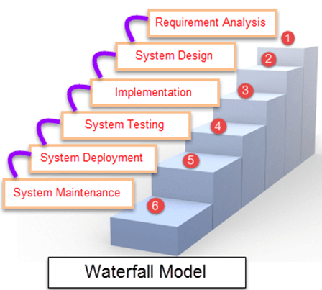
Waterfall Model
- Waterfall Model is a sequential model that divides software development into different phases. Each phase is designed for performing specific activity during SDLC phase. It was introduced in 1970 by Winston Royce.

Different Phases of Waterfall Model in Software Engineering
Different phases | Activities performed in each stage
Requirement Gathering stage | - During this phase, detailed requirements of the software system to be developed are gathered from client
Design Stage | - Plan the programming language, for Example Java, PHP, .net  - or database like Oracle, MySQL, etc.  - Or other high-level technical details of the project
Built Stage | - After design stage, it is built stage, that is nothing but coding the software
Test Stage | - In this phase, you test the software to verify that it is built as per the specifications given by the client.
Deployment stage | - Deploy the application in the respective environment
Maintenance stage | - Once your system is ready to use, you may later require change the code as per customer request
Advantages of waterfall model:
- The requirements are clearly and accurately stated, they remain unchanged throughout the entire project development;
- Detailed documentation of each development stage provides resistance to changes in human resources – a new developer can quickly get all the necessary information;
- Careful planning of the project development structure reduces the number of problematic issues;
- The start and end points for each phase are set, which makes it easy to measure progress;
- The tasks remain as stable as possible throughout the development process;
- It provides easy control and transparency for the customer due to a strict reporting system;
- Release date for the finished product, as well as its final cost can be calculated prior to development.
Disadvantages of the Waterfall Model:
- All requirements must be known prior to development, which greatly delays the project kickoff;
- Low flexibility level makes it difficult to make changes while developing, or even makes it completely impossible;
- There is a need for strict management and regular monitoring, so that the project will meet the deadline;
- The client does not have the opportunity to get acquainted with the system in advance, so he does not see the product until the moment of its completion;
- In case it becomes clear in the process of development that the product does not meet market requirements, there will be no room for changes.
Incremental Process Model:
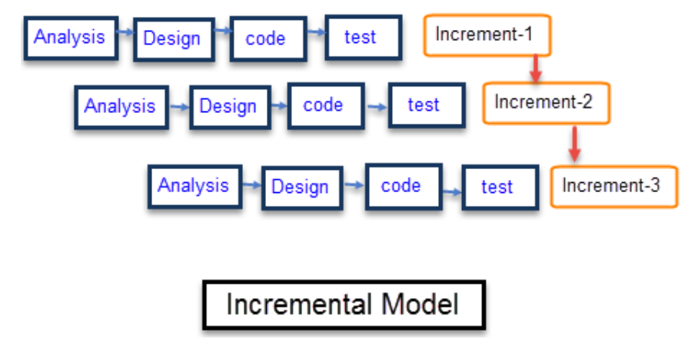
- Incremental Model is a process of software development where requirements are broken down into multiple standalone modules of software development cycle. Incremental development is done in steps from analysis design, implementation, testing/verification, maintenance.
- Each iteration passes through the requirements, design, coding and testing phases. And each subsequent release of the system adds function to the previous release until all designed functionality has been implemented.
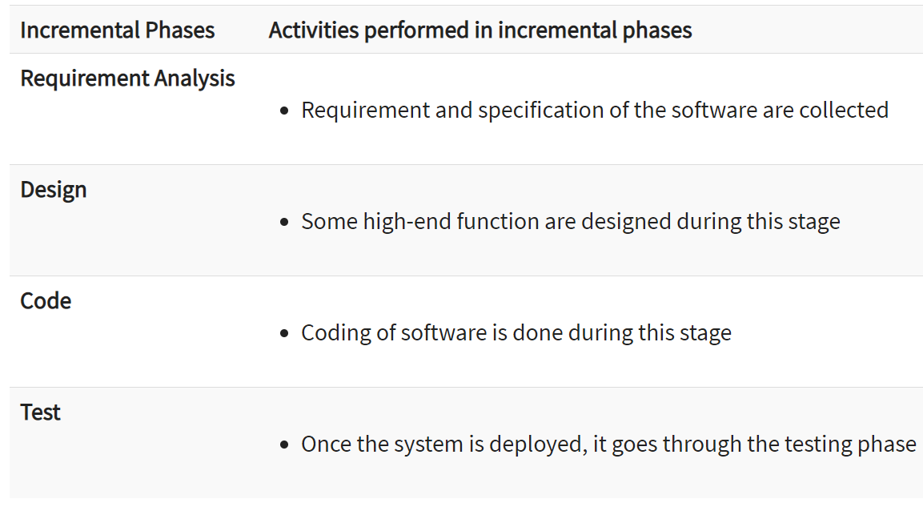
Advantages and Disadvantages of Incremental Model
Advantages | Disadvantages
- The software will be generated quickly during the software life cycle | - It requires a good planning designing
- It is flexible and less expensive to change requirements and scope | - Problems might cause due to system architecture as such not all requirements collected up front for the entire software lifecycle
- Throughout the development stages changes can be done | - Each iteration phase is rigid and does not overlap each other
- This model is less costly compared to others | - Rectifying a problem in one unit requires correction in all the units and consumes a lot of time
- A customer can respond to each building
- Errors are easy to be identified
When to use this :
- Funding Schedule, Risk, Program Complexity, or need for early realization of benefits.
- When Requirements are known up-front.
- When Projects having lengthy developments schedules.
- Projects with new Technology.
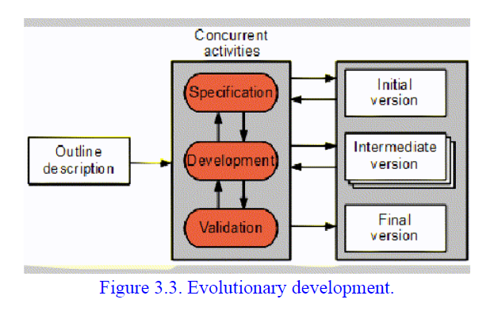
Evolutionary Process Models
- Evolutionary development is based on the idea of developing an initial implementation, exposing this to user comment and refining it through many versions until an adequate system has been developed (Figure 3.3). Specification, development and validation activities are interleaved with rapid feedback across activities.
- Evolutionary models are iterative type models.
- They allow to develop more complete versions of the software.
Following are the evolutionary process models:
1. The prototyping model
2. The spiral model
3. Concurrent development model
The Prototyping model:
- Prototype methodology is defined as a Software Development model in which a prototype is built, test, and then reworked when needed until an acceptable prototype is achieved. It also creates a base to produce the final system.
- Software prototyping model works best in scenarios where the project's requirement are not known. It is an iterative, trial, and error method which take place between the developer and the client.
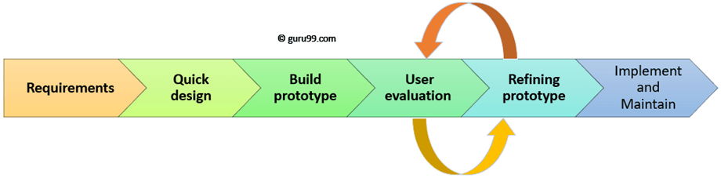
Prototyping Model has following six SDLC phases as follow:
Step 1: Requirements gathering and analysis
A prototyping model starts with requirement analysis. In this phase, the requirements of the system are defined in detail. During the process, the users of the system are interviewed to know what is their expectation from the system.
Step 2: Quick design
The second phase is a preliminary design or a quick design. In this stage, a simple design of the system is created. However, it is not a complete design. It gives a brief idea of the system to the user. The quick design helps in developing the prototype.
Step 3: Build a Prototype
In this phase, an actual prototype is designed based on the information gathered from quick design. It is a small working model of the required system.
Step 4: Initial user evaluation
In this stage, the proposed system is presented to the client for an initial evaluation. It helps to find out the strength and weakness of the working model. Comment and suggestion are collected from the customer and provided to the developer.
Step 5: Refining prototype
If the user is not happy with the current prototype, you need to refine the prototype according to the user's feedback and suggestions.
This phase will not over until all the requirements specified by the user are met. Once the user is satisfied with the developed prototype, a final system is developed based on the approved final prototype.
Step 6: Implement Product and Maintain
Once the final system is developed based on the final prototype, it is thoroughly tested and deployed to production. The system undergoes routine maintenance for minimizing downtime and prevent large-scale failures.
Types of Prototyping Models:
Four types of Prototyping models are:
- Rapid Throwaway prototypes
- Evolutionary prototype
- Incremental prototype
- Extreme prototype
Rapid Throwaway Prototype:
- Rapid throwaway is based on the preliminary requirement. It is quickly developed to show how the requirement will look visually. The customer's feedback helps drives changes to the requirement, and the prototype is again created until the requirement is baselined.
- In this method, a developed prototype will be discarded and will not be a part of the ultimately accepted prototype. This technique is useful for exploring ideas and getting instant feedback for customer requirements.
Evolutionary Prototyping:
- Here, the prototype developed is incrementally refined based on customer's feedback until it is finally accepted. It helps you to save time as well as effort. That's because developing a prototype from scratch for every interaction of the process can sometimes be very frustrating.
- This model is helpful for a project which uses a new technology that is not well understood. It is also used for a complex project where every functionality must be checked once. It is helpful when the requirement is not stable or not understood clearly at the initial stage.
Incremental Prototyping
- In incremental Prototyping, the final product is decimated into different small prototypes and developed individually. Eventually, the different prototypes are merged into a single product. This method is helpful to reduce the feedback time between the user and the application development team.
Extreme Prototyping:
- Extreme prototyping method is mostly used for web development. It is consists of three sequential phases.
- Basic prototype with all the existing page is present in the HTML format.
- You can simulate data process using a prototype services layer.
- The services are implemented and integrated into the final prototype.
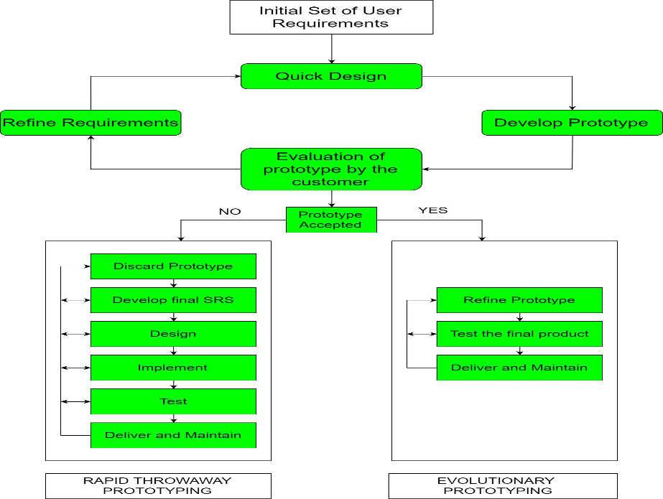
Advantages:
- The customers get to see the partial product early in the life cycle. This ensures a greater level of customer satisfaction and comfort.
- New requirements can be easily accommodated as there is scope for refinement.
- Missing functionalities can be easily figured out.
- Errors can be detected much earlier thereby saving a lot of effort and cost, besides enhancing the quality of the software.
- The developed prototype can be reused by the developer for more complicated projects in the future.
- Flexibility in design.
Disadvantages:
- Risk of insufficient requirement analysis owing to too much dependency on the prototype.
- Users may get confused in the prototypes and actual systems.
- Practically, this methodology may increase the complexity of the system as scope of the system may expand beyond original plans.
- Developers may try to reuse the existing prototypes to build the actual system, even when it is not technically feasible.
- The effort invested in building prototypes may be too much if it is not monitored properly.
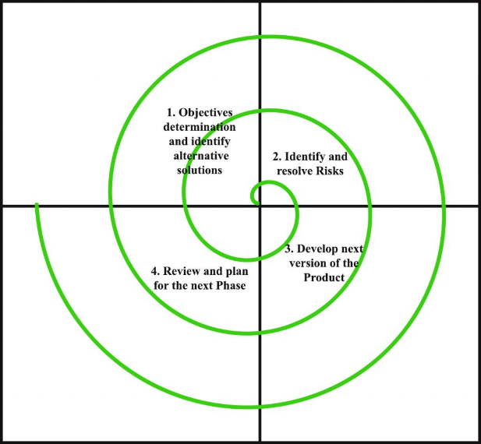
Spiral Model:
- Spiral model is one of the most important Software Development Life Cycle models, which provides support for Risk Handling. In its diagrammatic representation, it looks like a spiral with many loops. The exact number of loops of the spiral is unknown and can vary from project to project.
- Each loop of the spiral is called a Phase of the software development process. The exact number of phases needed to develop the product can be varied by the project manager depending upon the project risks. As the project manager dynamically determines the number of phases, so the project manager has an important role to develop a product using spiral model.
The functions of these four quadrants are discussed below-
- Objectives determination and identify alternative solutions: Requirements are gathered from the customers and the objectives are identified, elaborated and analyzed at the start of every phase. Then alternative solutions possible for the phase are proposed in this quadrant.
- Identify and resolve Risks: During the second quadrant all the possible solutions are evaluated to select the best possible solution. Then the risks associated with that solution is identified and the risks are resolved using the best possible strategy. At the end of this quadrant, Prototype is built for the best possible solution.
3. Develop next version of the Product: During the third quadrant, the identified features are developed and verified through testing. At the end of the third quadrant, the next version of the software is available.
4. Review and plan for the next Phase: In the fourth quadrant, the Customers evaluate the so far developed version of the software. In the end, planning for the next phase is started.

Risk Handling in Spiral Model
- A risk is any adverse situation that might affect the successful completion of a software project. The most important feature of the spiral model is handling these unknown risks after the project has started. Such risk resolutions are easier done by developing a prototype. The spiral model supports coping up with risks by providing the scope to build a prototype at every phase of the software development.
- Prototyping Model also support risk handling, but the risks must be identified completely before the start of the development work of the project. But in real life project risk may occur after the development work starts, in that case, we cannot use Prototyping Model. In each phase of the Spiral Model, the features of the product dated and analyzed and the risks at that point of time are identified and are resolved through prototyping. Thus, this model is much more flexible compared to other SDLC models.
Advantages of Spiral Model: Below are some of the advantages of the Spiral Model.
- Risk Handling: The projects with many unknown risks that occur as the development proceeds, in that case, Spiral Model is the best development model to follow due to the risk analysis and risk handling at every phase.
- Good for large projects: It is recommended to use the Spiral Model in large and complex projects.
- Flexibility in Requirements: Change requests in the Requirements at later phase can be incorporated accurately by using this model.
- Customer Satisfaction: Customer can see the development of the product at the early phase of the software development and thus, they habituated with the system by using it before completion of the total product.
Disadvantages of Spiral Model:
- Complex: The Spiral Model is much more complex than other SDLC models.
- Expensive: Spiral Model is not suitable for small projects as it is expensive.
- Too much dependable on Risk Analysis: The successful completion of the project is very much dependent on Risk Analysis. Without very highly experienced expertise, it is going to be a failure to develop a project using this model.
- Difficulty in time management: As the number of phases is unknown at the start of the project, so time estimation is very difficult.
Concurrent development model:
- The concurrent development model is called as concurrent model.
- The communication activity has completed in the first iteration and exits in the awaiting changes state.
- The modeling activity completed its initial communication and then go to the underdevelopment state.
- If the customer specifies the change in the requirement, then the modeling activity moves from the under development state into the awaiting change state.
- The concurrent process model activities moving from one state to another state. 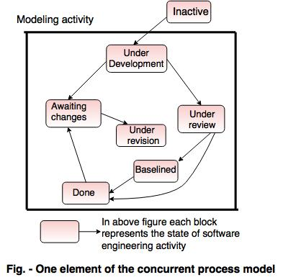
Advantages of the concurrent development model:
- This model is applicable to all types of software development processes.
- It is easy for understanding and use.
- It gives immediate feedback from testing.
- It provides an accurate picture of the current state of a project.
Disadvantages of the concurrent development model:
- It needs better communication between the team members. This may not be achieved all the time.
- It requires to remember the status of the different activities.
Unified Process:
- The Unified Software Development Process or Unified Process is a popular iterative and incremental software development process framework. The best-known and extensively documented refinement of the Unified Process is the Rational Unified Process(RUP). Other examples are OpenUP and Agile Unified Process.
- Unified process (UP) is an architecture-centric, use-case driven, iterative and incremental development process that leverages unified modeling language and is compliant with the system process engineering metamodel. Unified process can be applied to different software systems with different levels of technical and managerial complexity across various domains and organizational cultures.
- UP is also referred to as the unified software development process.
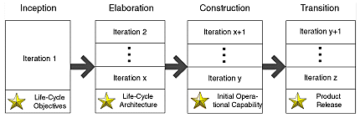
The UP defines the following four phases:
- The Inception phase, concluding with the Objective milestone, focuses on establishing the project's scope and vision; that is, establishing the business feasibility of the effort and stabilizing the objectives of the project.
- The Elaboration phase, concluding with the Architecture milestone, focuses on establishing the system's requirements and architecture; that is, establishing the technical feasibility of the effort and stabilizing the architecture of the system.
- The Construction phase, concluding with the Initial Operational Capability milestone, focuses on completing construction or building of the system.
- The Transition phase, concluding with the Product Release milestone, focuses on completing transitioning or deployment of the system to the user community.
Component-Based Development:
- Commercial off-the-shelf (COTS) software components, developed by vendors who offer them as products, provide targeted functionality with well-defined interfaces that enable the component to be integrated into the software that is to be built.
- The component-based development model incorporates many of the characteristics of the spiral model. It is evolutionary in nature [Nie92], demanding an iterative approach to the creation of software. However, the component based development model comprises applications from prepackaged software components.
- Modeling and construction activities begin with the identifi cation of candidate components. These components can be designed as either conventional software modules or object-oriented classes or packages 11 of classes.
The component-based development model incorporates the following steps (implemented using an evolutionary approach):
1. Available component-based products are researched and evaluated for the application domain in question.
2. Component integration issues are considered.
3. A software architecture is designed to accommodate the components.
4. Components are integrated into the architecture.
5. Comprehensive testing is conducted to ensure proper functionality.
The component-based development model leads to software reuse, and reusability provides software engineers with a number of measurable benefits including a reduction in development cycle time and a reduction in project cost if component reuse becomes part of your organization’s culture.
What is Agile Development?
- AGILE methodology is a practice that promotes continuous iteration of development and testing throughout the software development lifecycle of the project.
- The agile software development emphasizes on four core values.
- Individual and team interactions over processes and tools
- Working software over comprehensive documentation
- Customer collaboration over contract negotiation
- Responding to change over following a plan
- Agile is a software development methodology to build a software incrementally using short iterations of 1 to 4 weeks so that the development is aligned with the changing business needs.
- Agile is a software development methodology to build a software incrementally using short iterations of 1 to 4 weeks so that the development process is aligned with the changing business needs. Instead of a single-pass development of 6 to 18 months where all the requirements and risks are predicted upfront, Agile adopts a process of frequent feedback where a workable product is delivered after 1 to 4 week iteration.
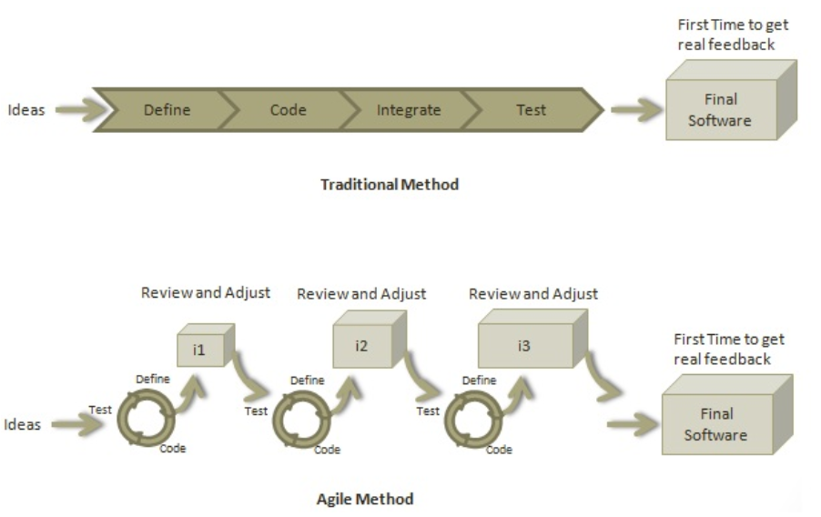
Principles of Agile Method:
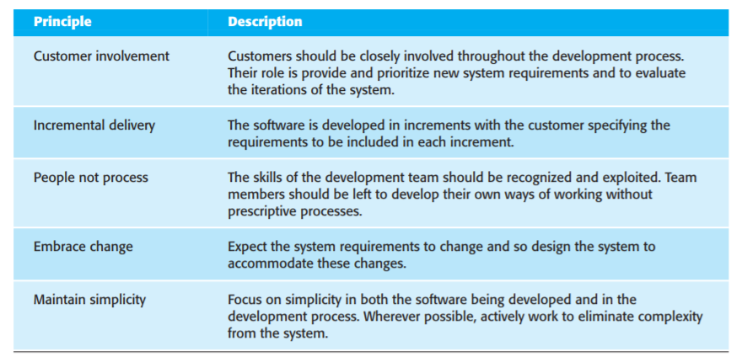
Plan-driven and agile development:
- Plan-driven processes are processes where all of the process activities are planned in advance and progress is measured against this plan.
- In agile processes, planning is incremental and it is easier to change the plan and the software to reflect changing customer requirements.
Agile approaches to software development consider design and implementation to be the central activities in the software process. They incorporate other activities, such as requirements elicitation and testing, into design and implementation. In an agile approach, iteration occurs across activities. Therefore, the requirements and the design are developed together, rather than separately
A plan-driven approach to software engineering identifies separate stages in the software process with outputs associated with each stage. The outputs from one stage are used as a basis for planning the following process activity. In a plan-driven approach, iteration occurs within activities with formal documents used to communicate between stages of the process. For example, the requirements will evolve and, ultimately, a requirements specification will be produced. This is then an input to the design and implementation process.
Plan-driven and agile specification:
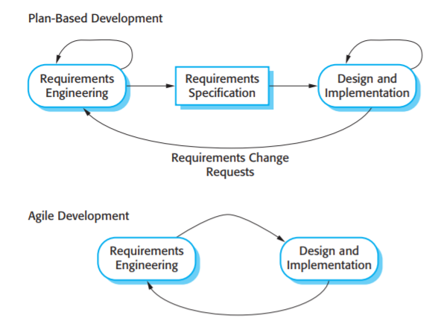
Extreme programming:
- Extreme Programming technique is very helpful when there is constantly changing demands or requirements from the customers or when they are not sure about the functionality of the system. It advocates frequent "releases" of the product in short development cycles, which inherently improves the productivity of the system and also introduces a checkpoint where any customer requirements can be easily implemented. The XP develops software keeping customer in the target.
XP Core Values:
The four core value of XP – communications, simplicity, feedback, and courage – drive its practices and project activities.
- Communication: One of the major causes of project failure has been a fact of open communication with the right players at the right time and at the right level. Effective communication involves not only documentation but also open verbal discussion. The practices and methods of XP are designed to ensure that open, frequent communication takes place.
- Simplicity: Developers have always advocated keeping solutions simple, they do not always follow their own advice. XP includes techniques to reinforce this principle and make it a standard way of developing systems.
- Feedback: Getting frequent and meaningful feedback is recognized as a best practice of software development. Feedback on functionality and requirements should come from the users, feedback on designs and code should come from other developers, and feedback on satisfying a business need should come from the client XP integrates feedback into every aspect of development.
- Courage: Developers always need courage to face the harsh choice of doing things right of throwing away bad code and starting over. But all too frequently they have not had the courage to stand up to a too right schedule, resulting in bad mistakes. XP practices are designed to make it easier to give developers the courage to “do it right.”
XP Practices:
- The Planning Process, sometimes called the Planning Game: The XP planning process allows the XP "customer" to define the business value of desired features, and uses cost estimates provided by the programmers, to choose what needs to be done and what needs to be deferred. The effect of XP's planning process is that it is easy to steer the project to success.
- There are two planning steps in XP: The Release planning: a practice where the customer presents the desired features to the programmers in the team who in return estimate their difficulty. Iteration planning: a practice whereby the team is given direction every couple of weeks building a software in 2-weeks “iterations” and delivering running useful software at the end of each iteration.
- Small Releases: XP teams put a simple system into production early, and update it frequently on a very short cycle. The team releases running, tested software, delivering business value chosen by the Customer, every iteration. The most important aspect is that the software is visible, and given to the customer, at the end of every iteration. This keeps everything open and tangible.
- Testing, also known as customer tests: XP teams focus on validation of the software at all times. Programmers develop software by writing tests first, then software that fulfils the requirements reflected in the tests. Customers provide acceptance tests that enable them to be certain that the features they need are provided. The best way for success is that once the test runs, the team keeps it running correctly thereafter.
- Metaphor: XP teams develop a common vision of how the program works, which we call metaphor. In other words they use a common "system of names" and a common system description that guides development and communication.
- Simple Design: A program built with XP should be the simplest program that meets the current requirements. There is not much building "for the future". Instead, the focus is on providing business value. Of course it is necessary to ensure that you have a good design. There are design steps in release planning and iteration planning, plus teams engage in quick design sessions and design revisions through refactoring, through the course of the entire project. In an incremental, iterative process like Extreme Programming, good design is then essential. That's why there is so much focus on design throughout the course of the entire development.
- Refactoring, or design improvement: Extreme Programming focuses on delivering business value in every iteration. To accomplish this over the course of the whole project, the software must be well designed. This is done by keeping the software clean: without duplication, with high communication, simple, yet complete. Refactoring is, of course, strongly supported by comprehensive testing to be sure that as the design evolves. Thus the customer tests are a critical enabling factor. The XP practices support each other: they are stronger together than separately.
- Pair Programming: XP programmers write all production code in pairs, two programmers working together at one machine. This practice ensures that all production code is reviewed by at least one other programmer, and results in better design, better testing, and better code. In fact, many experiments have shown that pair programming produces better software at similar or lower cost than programmers working alone.
- Collective Code Ownership: All the code belongs to all the programmers. This lets the team go at full speed, because when something needs changing, it can be changed without delay, which increases code quality and reduces defects.
- Continuous Integration: XP teams integrate and build the software system multiple times per day. This keeps all the programmers on the same page, and enables very rapid progress. Perhaps surprisingly, integrating more frequently tends to eliminate integration problems that plague teams who integrate less often
- Sustainable Pace sometimes known as 40-hour week: XP programmers work hard and at a pace that can be sustained indefinitely. This means they do not work overtime, unless it’s effective, keeping themselves fresh, healthy, as to reduce as much as possible mistakes.
- On-site Customer: An XP project is steered by a dedicated individual who is empowered to determine requirements, set priorities, and answer questions as the programmers have them. The effect of being there is that communication improves, with less hard-copy documentation - often one of the most expensive parts of a software project.
- Coding Standard: For a team to work effectively in pairs, and to share ownership of all the code, all programmers need to write the code in the same way, with rules that make sure the code communicates clearly.

Requirement Analysis and System Modeling
REQUIREMENT ENGINEERING
- A requirement is a feature of the system or a description of something the system is capable of doing in order to fulfill the system’s purpose.
- Requirements describe the “what” of a system, not the “how.”
- Requirements engineering produces one large document, written in a natural language, and contains a description of what the system will do without describing how it will do it.
- Requirements engineering is the systematic use of proven principles, techniques, and language tools for the cost-effective analysis, documentation, and on-going evaluation of the user’s needs and the specifications of the external behavior of a system to satisfy those user needs.
- It can be defined as a discipline, which addresses requirements of objects all along a system-development process.
Figure 3.1 illustrates the process of determining the requirements for a software-based system.
- The input to requirements engineering is the problem statement prepared by the customer.
- The output of the Requirements Engineering (RE) process is a system requirements specification called the Requirement Definition and Description (RDD).
- The system requirements specification forms the basis for designing software solutions.
PROCESS OF REQUIREMENTS ENGINEERING
Requirements engineering consists of the following processes:
- Requirements gathering (elicitation).
- Requirements analysis and modeling.
- Requirements documentation.
- Requirements review.
- Requirements management.
Figure 3.2 illustrates the process steps of requirements engineering.
Requirement Elicitation/Gathering.
- Requirement gathering is a communication process between the parties involved and affected in the problem situation.
- The tools in elicitation are meetings, interviews, video conferencing, e-mails, and existing documents study and facts findings. More than 90% to 95% elicitation should be complete in the initiation stage while the remaining 5% is completed during the development life-cycle.
- The requirements are gathered from various sources.
- The sources are:
- Customer (Initiator)
- End Users
- Primary Users
- Secondary Users
- Stakeholders
Requirement Analysis
- Requirement analysis is a very important and essential activity after elicitation.
- In this phase, each requirement is analyzed from the point-of-view of validity, consistency, and feasibility for firm consideration in the RDD and then in the SRS.
- Validity confirms its relevance to goals and objectives and consistently confirms that it does not conflict with other requirements but supports others where necessary.
- Feasibility ensures that the necessary inputs are available without bias and error, and technology support is possible to execute the requirement as a solution. This portion of the analysis confirms the place of the requirements in RDD on its own and along with others.
- The second portion of analysis attempts to find for each requirement, its functionality, features, and facilities and the need for these under different conditions and constraints.
- Functionality states “how to achieve the requirement goal.” Features describe the attributes of functionality, and facilities provide its delivery, administration, and communication to other systems.

Process Model of Elicitation and Analysis
The process activities are:
1. Domain Understanding. Analysts must develop their understanding of the application domain. For example, if a system for a supermarket is required, the analyst must find out how supermarkets operate.
2. Requirements Collection. This is the process of interacting with stakeholders in the system to discover their requirements. Obviously, domain understanding develops further during this activity.
3. Classification. This activity takes the unstructured collection of requirements and organizes them into coherent clusters.
4. Conflict Resolution. Inevitably, where multiple stakeholders are involved, requirements will conflict. This activity is concerned with findings and resolving these conflicts.
5. Prioritization. In any set of requirements some priorities will be more important than others. This stage involves interaction with stakeholders to discover the most important requirements.
6. Requirements Checking. The requirements are checked to discover if they are complete, consistent, and in accordance with what stakeholders really want from the system.
c) Requirements Documentation
- Requirements documentation is a very important activity, which is written after the requirements elicitation and analysis. This is the way to represent requirements in a consistent format. The requirements document is called the Software Requirements Specification (SRS).
d) Requirements Review
- A requirements review is a manual process, which involves multiple readers from both client and contractor staff checking the requirements document for anomalies and omissions.
- A requirements review can be informal or formal.
- 1. Informal Review. Informal reviews simply involve contractors discussing requirements with as many system stakeholders as possible. It is surprising how often communication between system developers and stakeholders ends after elicitation and there is no conformation that the documented requirements are what the stakeholders really said they wanted. Many problems can be detected simply by talking about the system to stakeholders before making a commitment to a formal review.
- 2. Formal Review. In a formal requirements review, the development team should ‘walk’ the client through the system requirements, explaining the implications of each requirement. The review team should check each requirement for consistency and should check the requirements as a whole for completeness.
- Requirements Management
- Requirements management is defined as a systematic approach to eliciting, organizing, and documenting the requirements of the system, and a process that establishes and maintains agreement between the customer and project team on the changing requirements of the system.
SRS DOCUMENT
- An SRS document is generated as the output of requirements analysis. Requirements analysis involves obtaining a clear and thorough understanding of the product to be developed.
- Thus, the SRS should be a consistent, correct, unambiguous, and complete document. The developer of the system can prepare an SRS after detailed communication with the customer.
- An SRS clearly defines the following:
- External interfaces of the system: They identify the information that is to flow ‘from and to’ to the system.
- Functional and non-functional requirements of the system: They are the findings of the run-time requirements.
- The functional requirements of the system as documented in the SRS document should clearly describe each function, which the system would support along with the corresponding input and output data set.
- The non-functional requirements deal with the characteristics of the system that cannot be expressed as functions. Examples of non-functional requirements include aspects concerning maintainability, portability, and usability. The non-functional requirements include aspects concerning maintainability, portability, and usability. The non-functional requirements may also include reliability issues, accuracy of results, human-computer interface issues, and constraints on the system implementation.
SRS VALIDATION
- It is extremely important to detect errors in the requirements document before going to other phases of system development.
- The major objective of SRS validation is to ensure that user requirements are complete and correctly recorded in the SRS and it is free from errors.
- It is also needed to check that the SRS itself is of good quality.
- Some of the most common types of errors in the SRS include:
1. Omission. Some user requirement is not included in the SRS. This error directly affects the external completeness of the system.
2. Inconsistency. Due to contradictions in requirements or incompatibility of state requirements.
3. Incorrect fact. Some facts recorded in the SRS are not correct.
4. Ambiguity. Some requirements have multiple meanings.
Besides improving the quality of the SRS, SRS validation should uncover and rectify all possible types of errors.
COMPONENTS OF SRS
The following requirements are used in the specification of the SRS:
1. Functional requirements
2. Performance requirements
3. Design constraints
4. External interface requirements
Functional Requirements
- Functional requirements specify what output should be produced from the given inputs. So they basically describe the connectivity between the input and output of the system. For each functional requirement:
- 1. A detailed description of all the data inputs and their sources, the units of measure, and the range of valid inputs be specified:
- 2. All the operations to be performed on the input data obtain the output should be specified, and
- 3. Care must be taken not to specify any algorithms that are not parts of the system but that may be needed to implement the system.
- 4. It must clearly state what the system should do if system behaves abnormally when any invalid input is given or due to some error during computation. Specifically, it should specify the behaviour of the system for invalid inputs and invalid outputs.
Performance Requirements (Speed Requirements)
This part of an SRS specifies the performance constraints on the software system. All the requirements related to the performance characteristics of the system must be clearly specified. Performance requirements are typically expressed as processed transactions per second or response time from the system for a user event or screen refresh time or a combination of these. It is a good idea to pin down performance requirements for the most used or critical transactions, user events and screens.
Design Constraints
- The client environment may restrict the designer to include some design constraints that must be followed. The various design constraints are standard compliance, resource limits, operating environment, reliability and security requirements and policies that may have an impact on the design of the system. An SRS should identify and specify all such constraints.
- Standard Compliance: It specifies the requirements for the standard the system must follow. The standards may include the report format and according procedures.
- Hardware Limitations: The software needs some existing or predetermined hardware to operate, thus imposing restrictions on the design. Hardware limitations can includes the types of machines to be used operating system availability memory space etc.
- Fault Tolerance: Fault tolerance requirements can place a major constraint on how the system is to be designed. Fault tolerance requirements often make the system more complex and expensive, so they should be minimized.
- Security: Currently security requirements have become essential and major for all types of systems. Security requirements place restriction s on the use of certain commands control access to database, provide different kinds of access, requirements for different people, require the use of passwords and cryptography techniques, and maintain a log of activities in the system.
External Interface Requirements
For each external interface requirements:
- 1. All the possible interactions of the software with people hardware and other software should be clearly specified,
- 2. The characteristics of each user interface of the software product should be specified and
- 3. The SRS should specify the logical characteristics of each interface between the software product and the hardware components for hardware interfacing.
CHARACTERISTICS OF SRS
1. Correctness: User review is used to ensure the correctness of requirements stated in the SRS. SRS is said to be correct if it covers all the requirements that are actually expected from the system.
2. Completeness: Completeness of SRS indicates every sense of completion including the numbering of all the pages, resolving the to be determined parts to as much extent as possible as well as covering all the functional and non-functional requirements properly.
3. Consistency: Requirements in SRS are said to be consistent if there are no conflicts between any set of requirements. Examples of conflict include differences in terminologies used at separate places, logical conflicts like time period of report generation, etc.
4. Unambiguousness: An SRS is said to be unambiguous if all the requirements stated have only 1 interpretation. Some of the ways to prevent unambiguousness include the use of modelling techniques like ER diagrams, proper reviews and buddy checks, etc.
5. Ranking for importance and stability: There should a criterion to classify the requirements as less or more important or more specifically as desirable or essential. An identifier mark can be used with every requirement to indicate its rank or stability.
6. Modifiability: SRS should be made as modifiable as possible and should be capable of easily accepting changes to the system to some extent. Modifications should be properly indexed and cross-referenced.
7. Verifiability: An SRS is verifiable if there exists a specific technique to quantifiably measure the extent to which every requirement is met by the system. For example, a requirement stating that the system must be user-friendly is not verifiable and listing such requirements should be avoided.
8. Traceability: One should be able to trace a requirement to a design component and then to a code segment in the program. Similarly, one should be able to trace a requirement to the corresponding test cases.
9. Design Independence: There should be an option to choose from multiple design alternatives for the final system. More specifically, the SRS should not include any implementation details.
10. Testability: An SRS should be written in such a way that it is easy to generate test cases and test plans from the document.
11. Understandable by the customer: An end user maybe an expert in his/her specific domain but might not be an expert in computer science. Hence, the use of formal notations and symbols should be avoided to as much extent as possible. The language should be kept easy and clear.
12. Right level of abstraction: If the SRS is written for the requirements phase, the details should be explained explicitly. Whereas, for a feasibility study, fewer details can be used. Hence, the level of abstraction varies according to the purpose of the SRS.
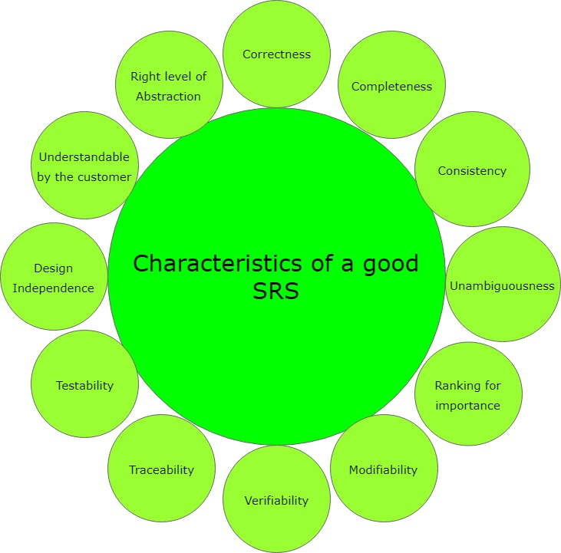

UML
Introduction
- UML (Unified Modeling Language) is a standard language for specifying, visualizing, constructing, and documenting the artifacts of software systems.
- UML was created by the Object Management Group (OMG) and UML 1.0 specification draft was proposed to the OMG in January 1997.
- It was initially started to capture the behavior of complex software and non-software system and now it has become an OMG standard.
- The goal of UML is to provide a standard notation that can be used by all object-oriented methods and to select and integrate the best elements of precursor notations. UML has been designed for a broad range of applications. Hence, it provides constructs for a broad range of systems and activities (e.g., distributed systems, analysis, system design and deployment).
- UML is a notation that resulted from the unification of OMT from
  - Object Modeling Technique OMT [James Rumbaugh 1991] - was best for analysis and data-intensive information systems.
  - Booch [Grady Booch 1994] - was excellent for design and implementation. Grady Booch had worked extensively with the Ada language, and had been a major player in the development of Object Oriented techniques for the language. Although the Booch method was strong, the notation was less well received (lots of cloud shapes dominated his models - not very tidy)
  - OOSE (Object-Oriented Software Engineering [Ivar Jacobson 1992]) - featured a model known as Use Cases. Use Cases are a powerful technique for understanding the behaviour of an entire system (an area where OO has traditionally been weak).
Role of UML in OO Design
- UML is a modeling language used to model software and non-software systems. Although UML is used for non-software systems, the emphasis is on modeling OO software applications. Most of the UML diagrams discussed so far are used to model different aspects such as static, dynamic, etc. Now whatever be the aspect, the artifacts are nothing but objects.
- Hence, the relation between OO design and UML is very important to understand. The OO design is transformed into UML diagrams according to the requirement. Before understanding the UML in detail, the OO concept should be learned properly. Once the OO analysis and design is done, the next step is very easy. The input from OO analysis and design is the input to UML diagrams.
Building blocks of UML
- Things
- Relationships
- Diagrams
Things
- Things are the most important building blocks of UML.
- Things can be −
- Structural
- Behavioral
- Grouping and Annotational
Structural Things

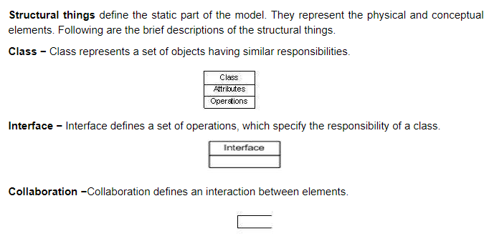
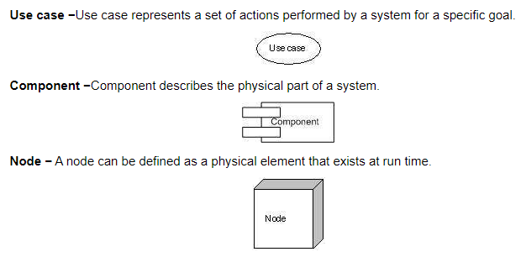
Behavioral Things
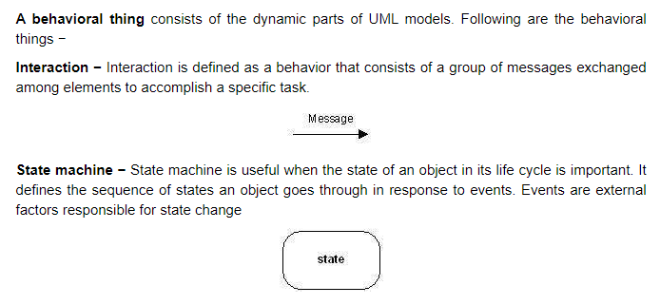
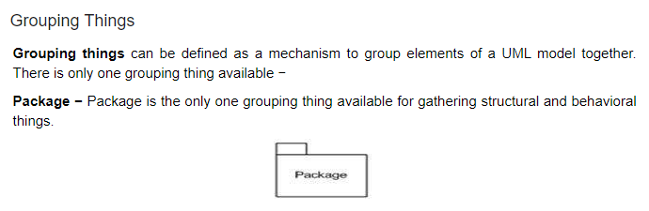
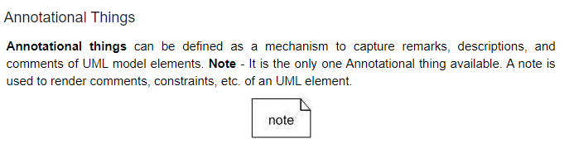
Relationship
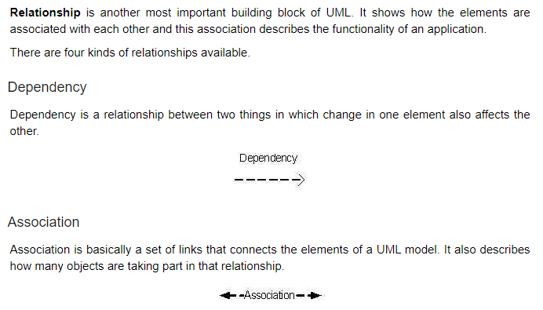
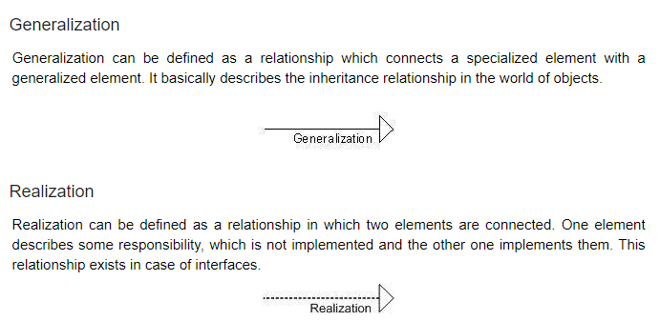
UML Diagrams
- UML diagrams are the ultimate output of the entire discussion. All the elements, relationships are used to make a complete UML diagram and the diagram represents a system.
- The visual effect of the UML diagram is the most important part of the entire process. All the other elements are used to make it complete.
- UML includes the following nine:
- Class diagram
- Object diagram
- Use case diagram
- Sequence diagram
- Collaboration diagram
- Activity diagram
- State chart diagram
- Deployment diagram
- Component diagram
UML - Modeling Types
- There are three important types of UML modeling.
a) Structural Modeling
- Structural modeling captures the static features of a system. They consist of the following −
- Classes diagrams
- Objects diagrams
- Deployment diagrams
- Package diagrams
- Composite structure diagram
- Component diagram
- Structural model represents the framework for the system and this framework is the place where all other components exist. Hence, the class diagram, component diagram and deployment diagrams are part of structural modeling. They all represent the elements and the mechanism to assemble them.
- The structural model never describes the dynamic behavior of the system. Class diagram is the most widely used structural diagram.
b) Behavioral Modeling
- Behavioral model describes the interaction in the system. It represents the interaction among the structural diagrams. Behavioral modeling shows the dynamic nature of the system.
- They consist of the following −
- Activity diagrams
- Interaction diagrams
- Use case diagrams
- All the above show the dynamic sequence of flow in a system.
c) Architectural Modeling
- Architectural model represents the overall framework of the system. It contains both structural and behavioral elements of the system. Architectural model can be defined as the blueprint of the entire system. Package diagram comes under architectural modeling.
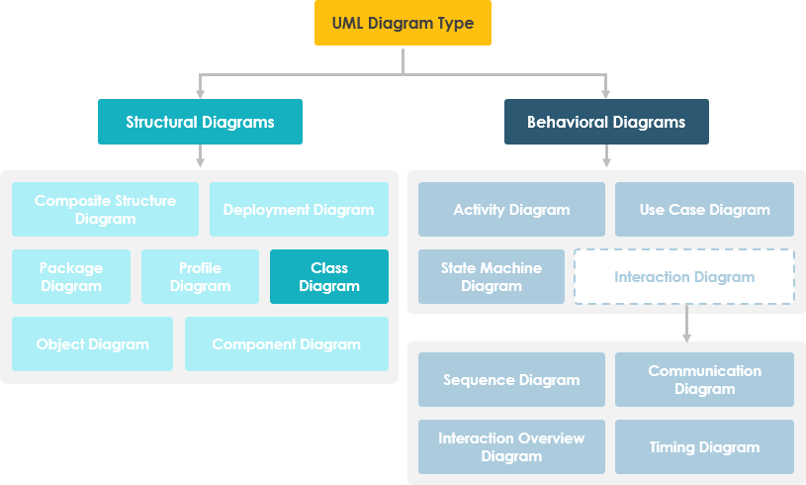
Use Case Diagrams
- A use-case model describes a system's functional requirements in terms of use cases.
- It is a model of the system's intended functionality (use cases) and its environment (actors).
- Use cases enable to relate what is needed from a system to how the system delivers on those needs.
- The purpose of use case diagram is to capture the dynamic aspect of a system.
- Use case diagrams are used to gather the requirements of a system including internal and external influences. These requirements are mostly design requirements. Hence, when a system is analyzed to gather its functionalities, use cases are prepared and actors are identified.
- When the initial task is complete, use case diagrams are modelled to present the outside view.
- Use Case Diagram captures the system's functionality and requirements by using actors and use cases.
- The purposes of use case diagrams can be said to be as follows −
- Used to gather the requirements of a system.
- Used to get an outside view of a system.
- Identify the external and internal factors influencing the system.
- Show the interaction among the requirements are actors.
When to use a use-case diagram?
- A purpose of use case diagram is to capture core functionalities of a system and visualize the interactions of various things called as actors with the use case. This is the general use of a use case diagram.
- The use case diagrams represent the core parts of a system and the workflow between them. In use case, implementation details are hidden from the external use only the event flow is represented.
- With the help of use case diagrams, we can find out pre and post conditions after the interaction with the actor. These conditions can be determined using various test cases.
- In general use case diagrams are used for:
- Analyzing the requirements of a system
- High-level visual software designing
- Capturing the functionalities of a system
- Modeling the basic idea behind the system
- Forward and reverse engineering of a system using various test cases.
Basic Use Case Diagram Symbols and Notations
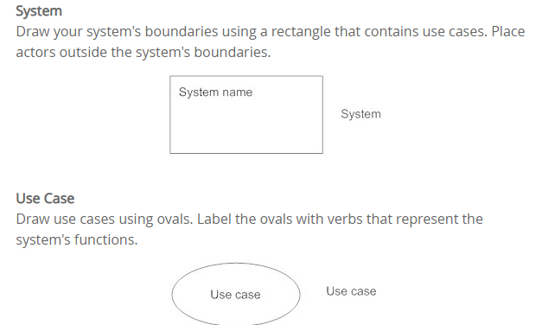
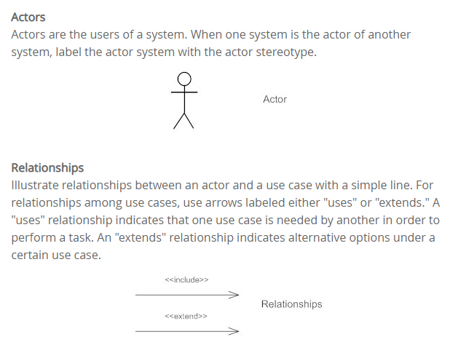
Association
An association is the relationship between an actor and a business use case. It indicates that an actor can use a certain functionality of the business system—the business use case:
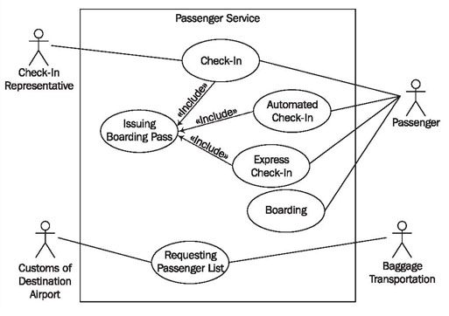
Class Diagram
- In software engineering, a class diagram in the Unified Modeling Language (UML) is a type of static structure diagram that describes the structure of a system by showing the system's classes, their attributes, operations (or methods), and the relationships among objects.
Purpose of Class Diagrams
- Shows static structure of classifiers in a system
- Diagram provides a basic notation for other structure diagrams prescribed by UML
- Helpful for developers and other team members too
- Business Analysts can use class diagrams to model systems from a business perspective
A UML class diagram is made up of:
- A set of classes and
- A set of relationships between classes
What is a Class?
- A description of a group of objects all with similar roles in the system, which consists of:
- Structural features (attributes) define what objects of the class "know"
  - Represent the state of an object of the class
  - Are descriptions of the structural or static features of a class
- Behavioral features (operations) define what objects of the class "can do"
  - Define the way in which objects may interact
  - Operations are descriptions of behavioral or dynamic features of a class
Essential elements of A UML class diagram
- Class Name
- Attributes
- Operations
Visibility of Class Members
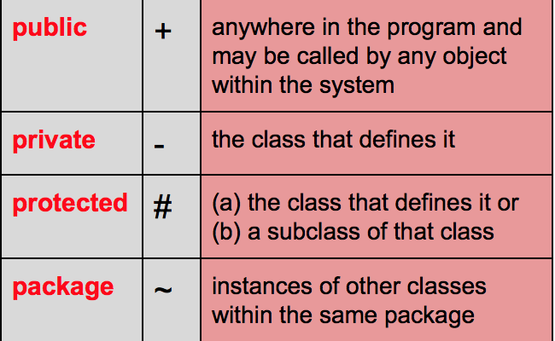
Relationships

